# Algorithm for file updates in Python

## Project description

At my organization, we manage who can access important content by using specific IP addresses. We have a file named "allow_list.txt" that keeps track of these addresses. I developed a simple program to help us automatically update this list whenever needed. The program looks at a separate list of IP addresses that should no longer have access, and it removes them from the main list in "allow_list.txt".

## Open the file that contains the allow list

I started by telling the program the name of the file we're working with:

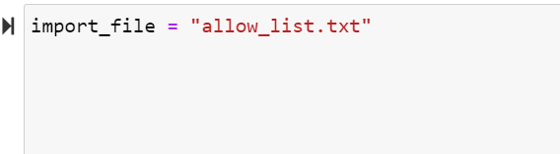

Then, using the with statement, I opened the file in read mode so we can take a look at its contents:

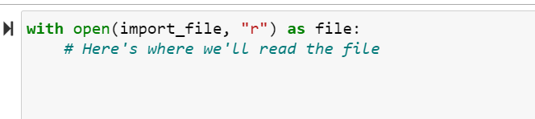

## Read the file contents

To read the contents of the file and turn them into something we can work with, I used the .read() method:

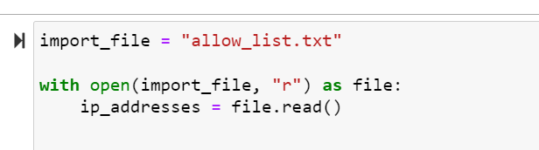

To gain insight into the content of the file, I read its contents and stored them as a string that can be manipulated.

## Convert the string into a list

To handle each IP address individually, I converted the string into a list using the .split() method:

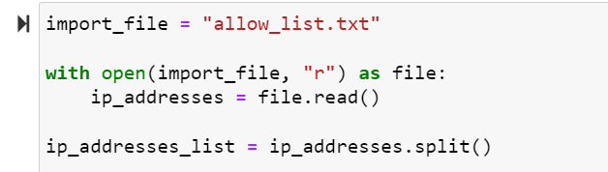

Here, I transformed the string content into a list format so that we can easily manipulate the IP addresses.

## Iterate through the remove list

I went through a list of IPs to remove using a for loop:

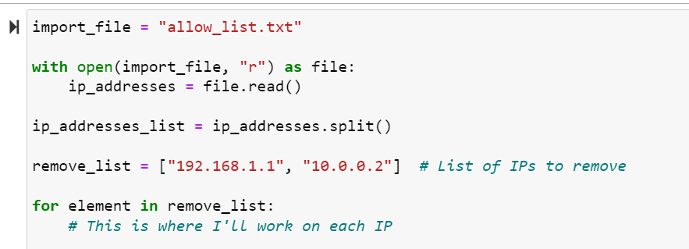

In this step, I set up a loop to process the list of IPs we want to remove one by one.

## Remove IP addresses that are on the remove list

Inside the loop, I checked if an IP address was in the main list and removed it if found:

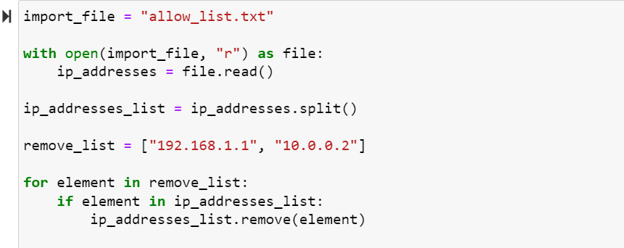

I carefully went through the list and removed the specific IPs we want to exclude, leaving us with a cleaned-up list.

## Update the file with the revised list of IP addresses

Finally, I transformed the list back into a string using the .join() method and wrote this string back into the file:

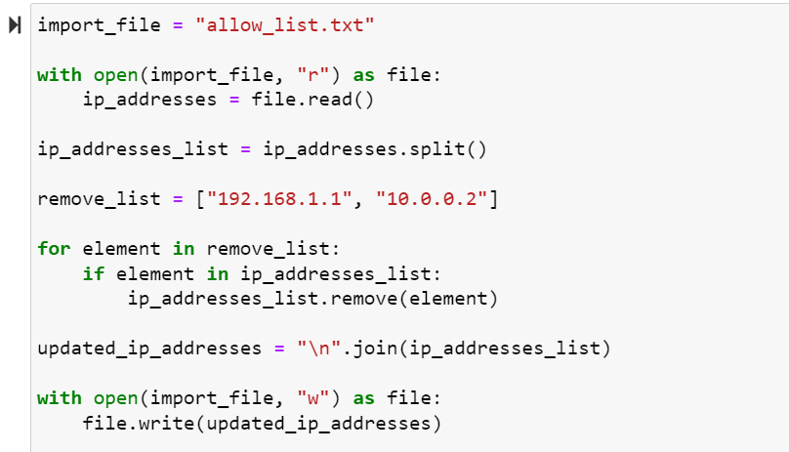

In this final step, I updated the file with the new list of IP addresses, ensuring that our access control remains accurate.

## Summary

My program automates updating a file that manages allowed IP addresses. I opened and read the "allow_list.txt" file, then converted its contents into a list. I used a loop to remove specific IP addresses from the list, and finally, I updated the file with the new list of IP addresses. This way, we can keep our content secure and accessible only to the right people.